**Mayukhmali**

**Materials:** Wood/Plastic, TF03-180 LiDAR.

**Design:** The entire RC boat design is made in the blender software as we were facing some difficulty to design it in a CAD software . Here, the boat can be made of wood or plastic but plywood is preferable due to better stability.

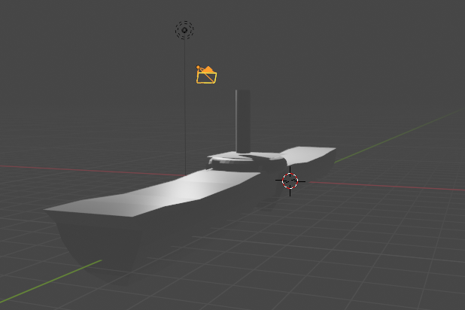

In all these diagrams the pole-like attachment is the lidar . The LiDAR also should be attached in the boat in such a way that the water does not affect the measurement. To do that, two boat-like structures are joined using a joining part and the LiDAR is attached to the top of that part .

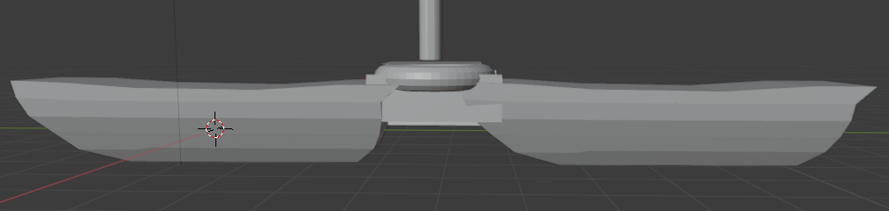

It is held up in such a way that water can’t affect it and there will be a little hole like structure in the donut shaped region through which the Laser will propagate. Due to the smaller aperture, the water can’t touch the LiDAR sensor.

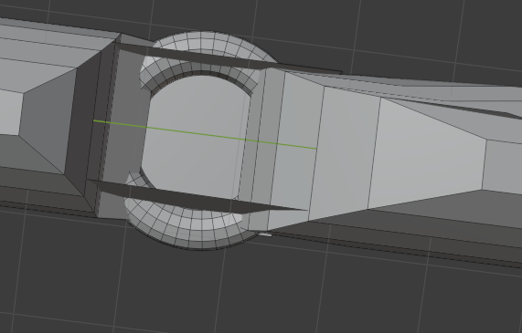

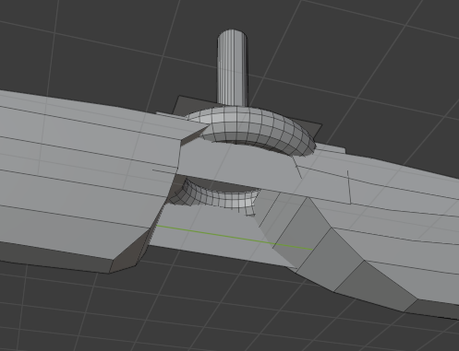

Also to avoid the accumulation of water in the junction we can add a propeller like disposal system .

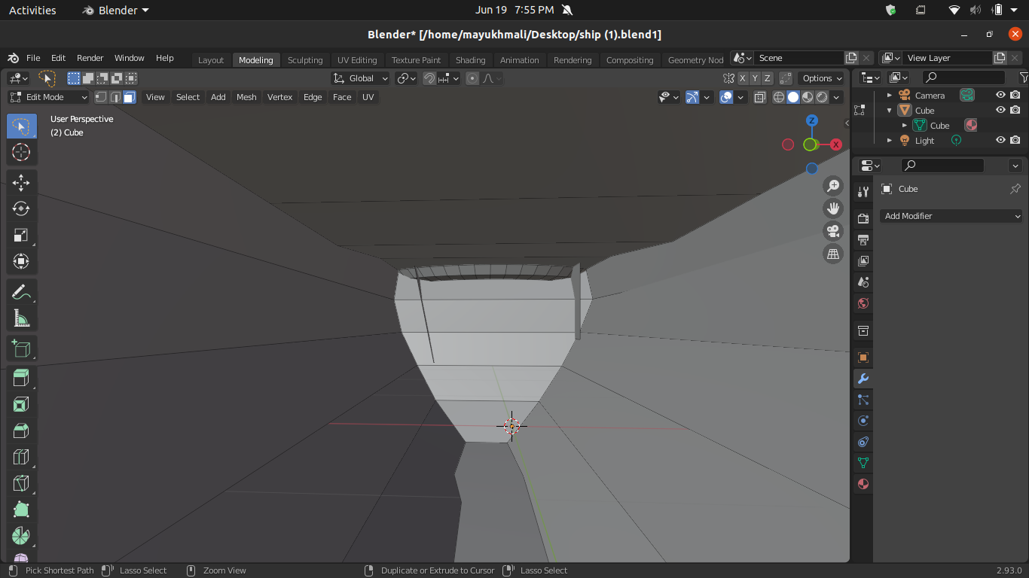

The above picture shows the interior of the boat where we can add a water disposal type system

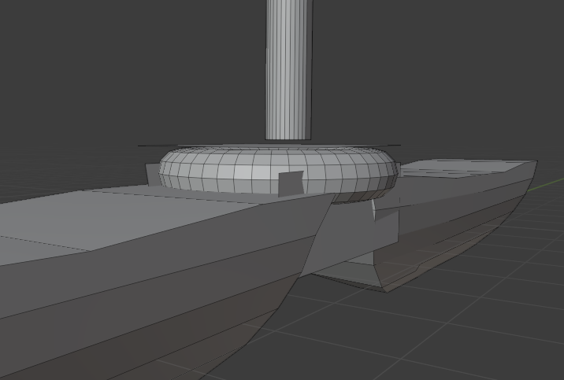

Through the circular area the Laser will travel and as there are guards on the two sides of the boat, it will be protected from water. Also, obstacle avoidance sensors and GPS can be placed in the upper portion of the boat. As there is amicable space for that. Also, the boat will be stable in the water as the buoyancy force will be cancelled out due to the weight of the boat passing through the centre of gravity.

The Blender File link is attached below:

<https://drive.google.com/file/d/1Qquzfb_c6nkpDQgp06mrdnESQ8x6Dxp3/view?usp=sharing>

**Gyroscope :**

Also as bathymetric lidars can face a lot of problems from the turbulence in water and also the ripples from vegetations nearby we must add a gyroscope in the boat , such that the lidar in the boat should start taking data only when the boat is in a completely stable state .

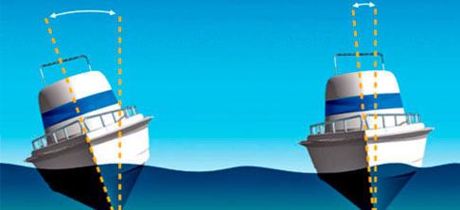

We can easily connect the gyroscope to a host microcontroller and then using this we can control the lidar . That is when it should take data and when it should not . We will stay at a particular position until the “ N “ number of readings are taken . The time for each will vary according to turbulence . Then we will average the data to get approximate depth at points .

**GPS Utility : ( optional )**

Also during the taking of “ N “ readings the boat may be shifted to another point . So we have to generate an autonomous system so that the boat can come back to that point . We can use a GPS system coupled with servos and microcontrollers for this process .

**Graphical interface of Lidar :**

<https://www.hackster.io/TravisLedo/arduino-lidar-scanning-java-rendering-6b2124>

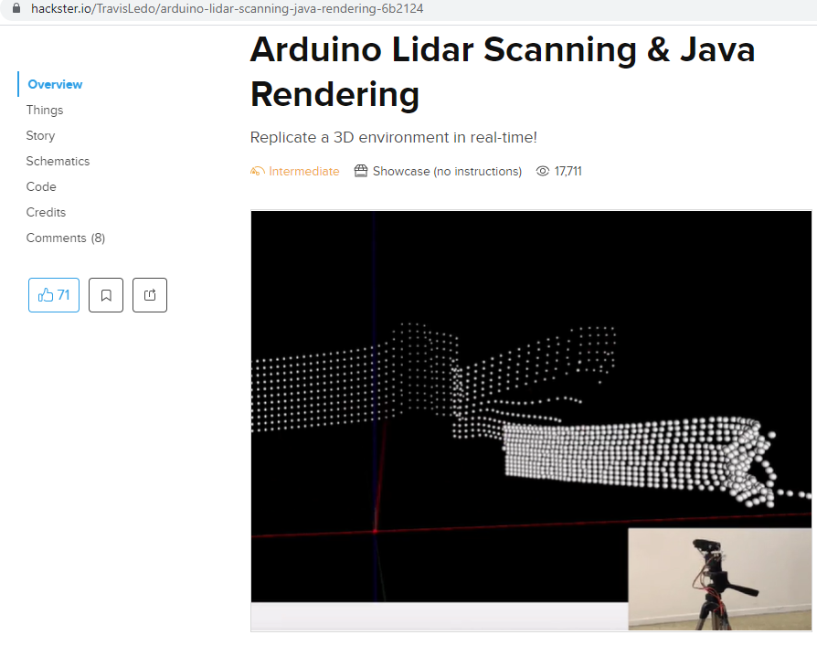

Various ideas of how to implement our model can be found in this link :

<https://www.hackster.io/search?i=projects&q=lidar>

Also we must use bathymetric lidars . Normal Lidars would not suffice the task . Now sometimes errors may come in reading due to various issues arising from ripples , reflection , total internal reflection and others So some algo must be used to eliminate these type of errors .